Profiles of Emerging Innovation Leaders

Student’s Name
Department, University Name
Course Code: Course Name
Instructor’s Name
Date of Submission

Profiles of Emerging Innovation Leaders
Introduction
Most of the economists have identified that among the emerging economies in Asia, the two have indicated the most striking development in India and China. The two counties are having continuous growth in their economy. The two are recording a positive increase in their economic growth because of the new entry of several multinational corporations in their markets. We have to understand that multinational corporations do not just enter into any market without clearly undertaking a study of the existence of businesses in any country. Choosing the country to enter is the most important strategic decision that multinationals are normally facing. The companies have to meet these strategic decisions when they are internalizing (Roper, 2013). Therefore, the two countries are providing the best market for various companies around the globe. The two countries are provided with the best policies that encourage the entry of new firms. Growth is very important for any country as it will encourage many businesses to enter the market (Toibaeva, 2019). The country must provide good working policies that would encourage the establishment of corporations.
Criteria for Judging the Two Economies and Performance
The performance of an economy of any given country is normally assessed in terms of the achievement of its economic objectives. A country’s economic objectives can either be long-term, like having sustainable growth, or short-term like stabilization of its economy. In these two countries, China and India, the criteria am using to judge their economic performance are the level of the real national income, the general output and the spending. The three key variables are the best indicators to confirm if an economy is performing. The real national income and gross domestic product of both China and India are seen to be having a continuous positive increase. The citizens in these two countries are also having a high level of savings and saving ratios. Every citizen needs to have a good saving level as this would encourage investments. The two countries are seen to be recording a tremendous increase in their total gross domestic product (GDP). The countries are a high number of multinational corporations as a result of good working policies provided by the government.
Why Innovation and Entrepreneurship is Important to China and India
Innovation is essential to both China and India as it is considered a driver of economic progress that would benefit businesses, the consumers and the economy as a whole. It plays a significant role in ensuring that there is a positive growth of the economy and improvement of the living standards. Both China and India highly need innovation to ensure that they continue to be one of the best emerging economies. As already stated, the most important benefit of innovation is the contribution it has on economic growth. This simply means that innovation can easily lead to higher productivity (Alsolami & Teoh, 2016). The idea is that the same input of the factor of production generates a greater output. Most economists have identified that as productivity rises, more commodities will be produced. Therefore, innovation and entrepreneurship lead to the growth of the economy and general living standards.
China and India need innovation because both innovation and growth in productivity would bring a great benefit for businesses and consumers. An increase in productivity would increase the wages for the workers. There would be more money in circulation and thus, would have enough to buy more commodities in the market. This would mean an increase in profit margin for the businesses. A high profit margin would enable the organization to invest and employ more workers.
A profile of China
Basic Information and Current Position in the Global Economy
China is considered to be the third-largest country by area in the world with 9.6 million square kilometers. The country has an east-west extent of 5,000 km and a north-south extent of 3,900 km. China is considered to be the fastest-growing country in the world in terms of people with a total population of about 1.398 billion people as of 2019 (Jung & Zhou, 2019). The country is having a continuous population growth. This is seen by most of the economies as very advantageous to most of the corporations in the country. It is seen to be very mountainous with almost 33 per cent of its territory being mountainous and about 10 per cent hills (Jung & Zhou, 2019). It also has about 25 per cent being high plateaus. The country has international borders of 14 countries like Tajikistan, Afghanistan, Russia, Thailand, Vietnam, and North Korea.
During the initiation of trade liberalization and economic reforms almost 40 years ago, China had policies that kept its economy stagnant, poor, centrally controlled, mostly insufficient, and highly isolated from the global economy. This state of the country affected the lives of the majority of Chinese, who suffered the diverse effect of this system of economy. In 1979, the government of China decided to open its economy and to allow for foreign trade (Ahlstrom & Ding, 2015). The decision to open up foreign trade and the implementation of the free-market reforms has made the country to be among the fastest-growing economies in the world.
The country recorded an annual gross domestic product (GDP) growth of about 9.5 per cent in 2018. The pace was considered by the World Bank as the fastest ever obtained expansion of the economy in history. Such a positive growth rate has enabled the country to be on average and to double its gross domestic product (GDP) in almost every eight (Roper, 2013). This kind of situation has helped to raise over 800 million people to be out of the risk of poverty. Most scholars have identified that China has become one of the world’s largest economies, especially as a manufacturer, purchasing power parity basis, foreign exchange reserves holder, and good merchandise trader. This has made China be one of the strongest partners of the United States.
Strategies Taken by China to Promote Innovation and Entrepreneurship
Today the economy of China has matured, the real gross domestic product (GDP) growth is growing significantly from about 6.7 per cent in 2007 to about 14.2 per cent in 2014 (Jung & Zhou, 2019). The growth of the country is estimated by the International Monetary Fund (IMF) to increase to about 15. 1 per cent by the end of 2024 (Thompson & Huggins, 2015). The government of China has embraced the economic growth rate at their new normal and they are doing all that is take to improve on the trend. The country is using a new growth model where it relies less on that fixed investment and they encouraging the citizens to be more on private consumption and innovations. These are the strategies that they believe will encourage and drive a more positive growth rate.
The reforms are needed to help the country avoid hitting the middle-income trap. The new sources of economic growth like innovation are the main factors being used by China to foster positive growth. This kind of growth rate is encouraging several multinational corporations to see China as the best country to enter. The country is providing an ideal environment for businesses to participate fully. China has declared innovation to be the key priority in planning for its economy. The Chinese are planning their economy through the use of several high-profile initiatives. For instance, in 2015, the government announced an initiative called “Made in China 2025,” The main objective of the plan is to modernize and upgrade the manufacturing of China in almost ten key sectors (Ozukul, 2020). The plan is to be done through extensive government assistance to ensure that the country is made to be one of the greatest players in those key sectors. The country is working hard using various policies to ensure that it overpowers other established economies like the United States. The country wants all its multinational corporations to dominate the global market.
Results of the Strategies Taken to Date
The statistics from the World Bank have indicated that China is one of the leading manufacturers in the world. In figure 1 below, there is a list of estimates of the gross value of manufacturing in China, Japan, and the United States. The figure has indicated that one is performing best in the manufacturing sector. In 2016, the value of manufacturing in China on the gross value was 48.9 per cent higher than that of the United States. Most economists argue that manufacturing plays a vital role in the growth of any economy (Hoogendoorn, 2016). Therefore, China greatly improved in its key economic sectors because it decided to heavily invest in the manufacturing sector. The sector plays a fundamental role in improving the economy of China than it does in the United States. In the same year, the gross value-added manufacturing of China was about 27.9 per cent compared to that of the United States, which was 12.1 per cent (Silver, 2016).
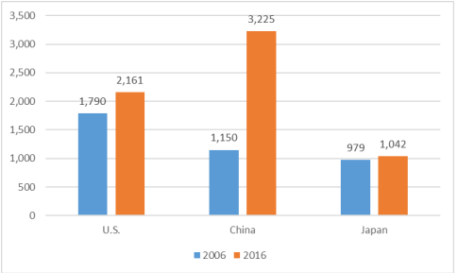
Figure 1: Gross Value-Added Manufacturing 2006 and 2016, Source, the World Bank
The country has continued to record this positive growth rate because of the good business environment. The government implemented some of the policies that were majorly based on improving manufacturing industries in the country. It is for this reason that many computer technology companies like Lenovo are established in China. As an emerging economy, China also has highly trained and educated labour, which comprises engineers and scientists (Jung & Zhou, 2019). The highly skilled labour has caused a rapid growth of the domestic markets, especially for high-tech products in the country.
Challenges Encountered in Encouraging Innovation and Entrepreneurship and How they Have Been Overcome
The People’s Republic of China has been enjoying significant economic growth at an average of about 8 per cent annually (Ahlstrom & Ding, 2015). The recently founded private firms are increasing at a very high rate and becoming the steady economic development in the country. However, some certain barriers and challenges are facing entrepreneurship and innovation in China. The main challenge of entrepreneurship and innovation in the country is the lack of start-up financing programs (Ahlstrom & Ding, 2015). The country lacks proper loan funds and public sector subsidies programs. In some cases, the country has a high cost of labour and a high level of competition. Financial support is a very important aspect of every country’s development strategy. Therefore, these challenges have created a reduction in the growth of some of the locally owned companies in the country. The government has to find the right solution for this challenge to increase the high productivity level in the country.
To maintain and improve economic growth, the government must find ways to address these challenges in the most professional way. The barriers should be reduced and removed as they significantly hinder economic development. Lack of proper start-up financing programs is one area that is affecting innovation Entrepreneurship in China (Assogbavi, 2021). The government is currently implementing various programs that would ensure that the majority of the investors, especially in the manufacturing industry, are helped and encouraged financially.
Implications for other Emerging Economy Countries
China is considered to be the largest United States merchandise trading partner. However, despite being the partner of the U.S in foreign trade business, Chine is one country causing a significant threat to the economy of the United States (Roper, 2013). The growing global economic influence of China and some of its foreign trade policies are seen to have a significant implication for the countries like the United States firms. Most economists have stated that the incomplete transition of the country to a free-market economy is seen to be harmful to the economic interest of the United States. Some of the policies that are seen to be harmful to the U.S are the industrial policies and some theft of the country’s intellectual property (Roper, 2013). Therefore, this implies that other emerging economy countries can do well and overpower serious superpowers like the United States. The countries must have better strategies to improve on the economic growth.
A profile of India
Basic Information and Current Position in the Global Economy
India is one of the most populated countries in the world, with a total of 1.32 billion people. This is seen to be more than one-sixth of the global population. India is centrally located between West and East Asia. It is extended to the Southward of the Asian continent. Most economists have identified that the Trans Indian Ocean routes that connect the countries of Europe in the West and the countries of East Asia is responsible for providing the strategic location of India. It has been identified that India is a vast country that is lying entirely in the Northern hemisphere. The land extends to the latitude of 8°4’N and 37°6’N and longitudes of 68°7’E and 97°25’E (Raghbendra, 2017).
The country is a democratic republic with a ceremonial president. The prime minister is the head of the government and the one who runs the cabinet. India is one of the largest countries by area in the world covering about 3.3 million square kilometers. India has emerged to be one of the fastest-growing economies in the world. The country is currently expected to be one of the top three best economic power in the world in the next 9 to15 years (Raghbendra, 2017). This can be witnessed by its robust democracy and strong economic partnerships around the globe. The country has a positive growth rate in almost every sector of the economy.
The real gross domestic product (GDP) of India is reported to be at about US$ 1.82 trillion. This is according to the provisional estimates of the country’s annual national income from 2019-2021. Most studies have indicated that India is the fourth largest unicorn-based economy in the world. The country has over 21 unicorns, which is valued at about US$ 73.2 billion (Thompson & Huggins, 2015). It is estimated that the country will have about 100 unicorns by the year 2025. This will be beneficial to most of the citizens of India as it will create about 1.1 million direct employment. The country wants to increase its employment rate and create about 92 million formal jobs. The target is expected to be achieved between 2023 and about 2030. To achieve this target, the net employment rate should grow by about 1.4 per cent every year between the set years of 2023 and 2030. According to Brixiova (2013), the foreign exchange reserves in India have increased by about US$ 6.842 and have reached a total of US$ 605 billion (Raghbendra, 2017).
Strategies Taken by India to Promote Innovation and Entrepreneurship
The government has come up with several strategies to promote innovation and entrepreneurship in the country. The strategies were meant to ensure that India has continued to open its market to various multinational corporations. Opening up the economy for foreign investors would improve economic growth and development in almost all the sectors in the country. The first strategy the government took was on its first Union Budget of the third decade. The budget was presented by the country’s Finance & Corporate Affairs Minister in February of 2019. The budget had the main responsibility of energizing the economy of India by a combination of long-term, medium, and short-term measures of economic development. In the budget, the capital expenditure for FY22 was increased to about 33.9 per cent, which is US$ 77.81 billion (Raghbendra, 2017). The main reason was to have a significant boost in the country’s economy.
The government also wanted to have an increase in its expenditure. This was meant to attract a large number of private investors, both local and foreign. The idea is to have a high number of corporations being established in the country. The government has proactive and measured policies that are meant to support and boost the economy of the country. In 2020, the government decided to approve a production-linked incentive (PLI) to manufacture advanced chemistry cells (ACC). The initiative was to boost the sector and the company was given a total of about US$ 6.07 billion. The various initiatives have made several foreign companies be based in the country. This has greatly improved the economy of India (Raghbendra, 2017).
Results of the Strategies Taken to Date
The strategies taken by the Indian government have led to a significant increase in economic growth. The country is having a tremendous increase in productivity, which has improved the country’s gross domestic product. The growth of this economy is threatening already established economies like the United States. Figure 2 clearly indicates a progressive increase in India’s gross domestic product since the 1960s (Raghbendra, 2017).
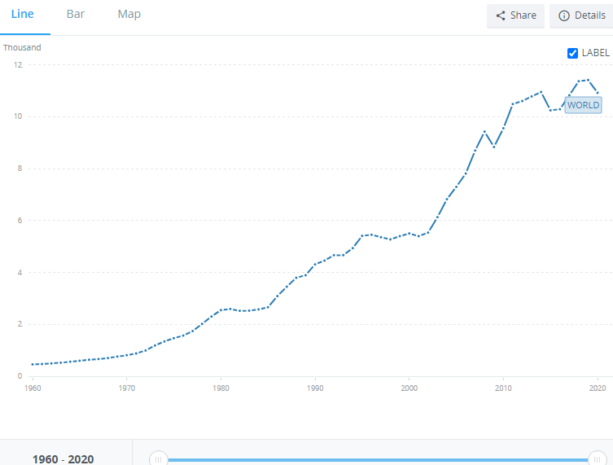
Figure 2. The per capita income of India since 1960(Source: The World Bank)
Challenges Encountered in Encouraging Innovation and Entrepreneurship and How They Have Been Overcome
The state of Indian is making the country to be more entrepreneurial, which has been brought by innovation. The country is experiencing an increase in economic growth and an improvement in living standards. This has been caused by an increase in the level of productivity in the country. However, several challenges are being encountered while encouraging innovation and Entrepreneurship. Some of the challenges in innovation are political risks, corruption and lack of financial support. The country is an emerging economy that is suffering some political instability and poverty. The political instability is creating a great challenge to the development of the economy. Corruption is also a serious threat to the development of a country (Bena, 2014). It is making more corporations from fairing the risk of having a low-profit margin. Therefore, it is the responsibility of every government to reduce corruption in all sectors of the government.
Implications for Other Emerging Economy Countries
The companies are always looking for countries that are more peaceful and provide an ideal working environment. Multinationals are looking for countries with high advertising intensity. This normally makes them easily internalize their operations and protect their brand. Therefore, the emerging economies have to continue providing a better working environment as this will improve the living standard. Other emerging economies have to learn from the strategies that are being used by India. They should understand that they can also overpower the other already established economies.
Conclusion
The policymakers in every business organization are put to ensure that it decision made is for the benefit of the company. Therefore, before a company can expand or enter into any market, it has to ensure that the country has got more favourable policies. In the recent past, China and India have been recording a tremendous increase in the economy. This has made china to be among the top superpower countries in the world, causing a significant threat to an established economy like the United States. Therefore, the two countries have provided the best working environment for these multinational corporations.

References
Ahlstrom, D., & Ding, Z. (2015). Entrepreneurship in China: Progress and challenges. Developments in Chinese entrepreneurship: Key issues and challenges, 1-32.
Alsolami, H. A., & Teoh, K. (2016). Revisiting Innovation Leadership. Open Journal of Leadership, 20-38.
Assogbavi, K. K. (2021). Global Account Imbalances since the Global financial crisis: Determinants, Implications, and Challenges for the Global Economy. Implications and Challenges for the Global Economy, 20-44.
Bena, Y. B. (2014). A study on the challenges faced by the Entrepreneurs. Journal of PSGR Krishnammal College for Women, 1-7.
Brixiova, Z. (2013). Modelling productive entrepreneurship in developing countries. Small Business Economics volume, 183-194.
Hoogendoorn, B. (2016). The Prevalence and Determinants of Social Entrepreneurship at the Macro Level. Journal of Small Business Management, 278-296.
Jung, S., & Zhou, X. (2019). China’s 40-year road to innovation. Chinese Management Studies ahead-of-print(ahead-of-print), 12-70.
Ozukul, G. (2020). The effect of economic freedom on entrepreneurship in Islamic countries. Journal of Mehmet Akif Ersoy University Economics and Administrative Sciences Faculty (MAKU IIBFD), 1-7.
Raghbendra, J. (2017). The Indian Economy: Current Performance and Short-Term Prospects. SSRN Electronic Journal, 12-84.
Roper, S. (2013). Entrepreneurship: A global perspective. New York: Routledge.
Silver, C. (2016). The Top 25 Economies in the World. Ranking the Richest Countries in the World, 1-9.
Thompson, P., & Huggins, R. (2015). Entrepreneurship, innovation, and regional growth: a network theory. Small Business Economics, 103-128.
Toibaeva, S. (2019). About the Concept of Information Support System for Innovative Economy in the Republic of Kazakhstan. International Conference on Information Technologies, 1-7.

